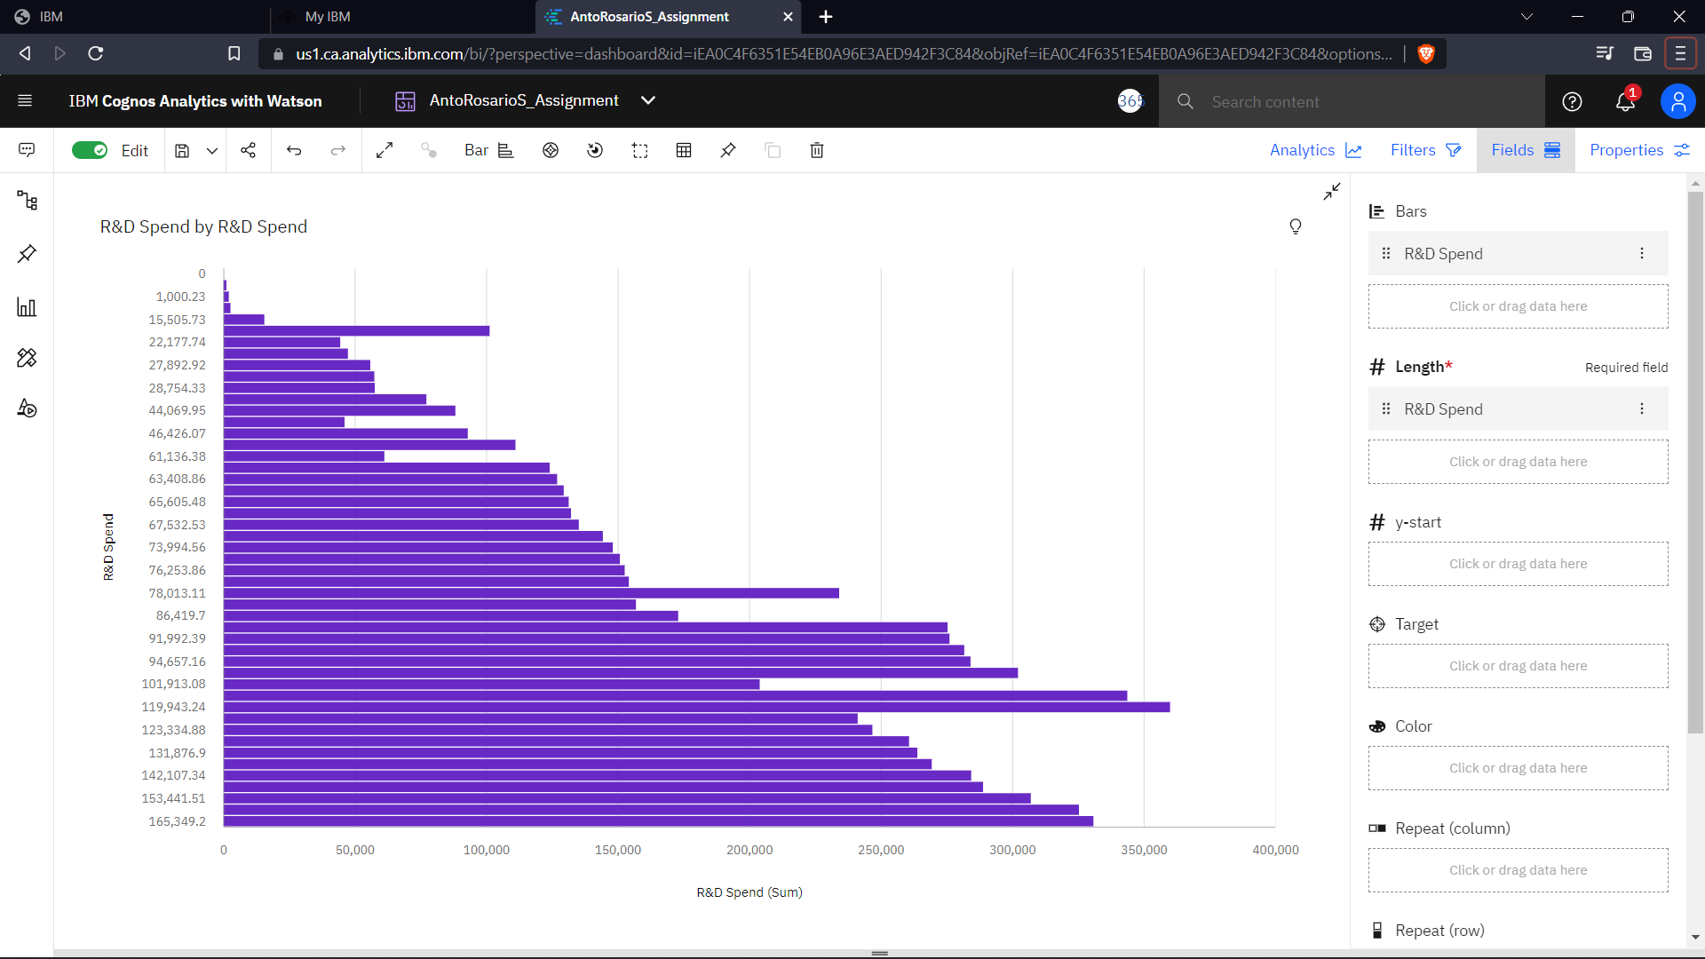

<https://us1.ca.analytics.ibm.com/bi/?perspective=dashboard&pathRef=.my_folders%2FAntoRosarioS_Assignment&action=view&mode=dashboard&subView=model00000183829bdf29_00000000>

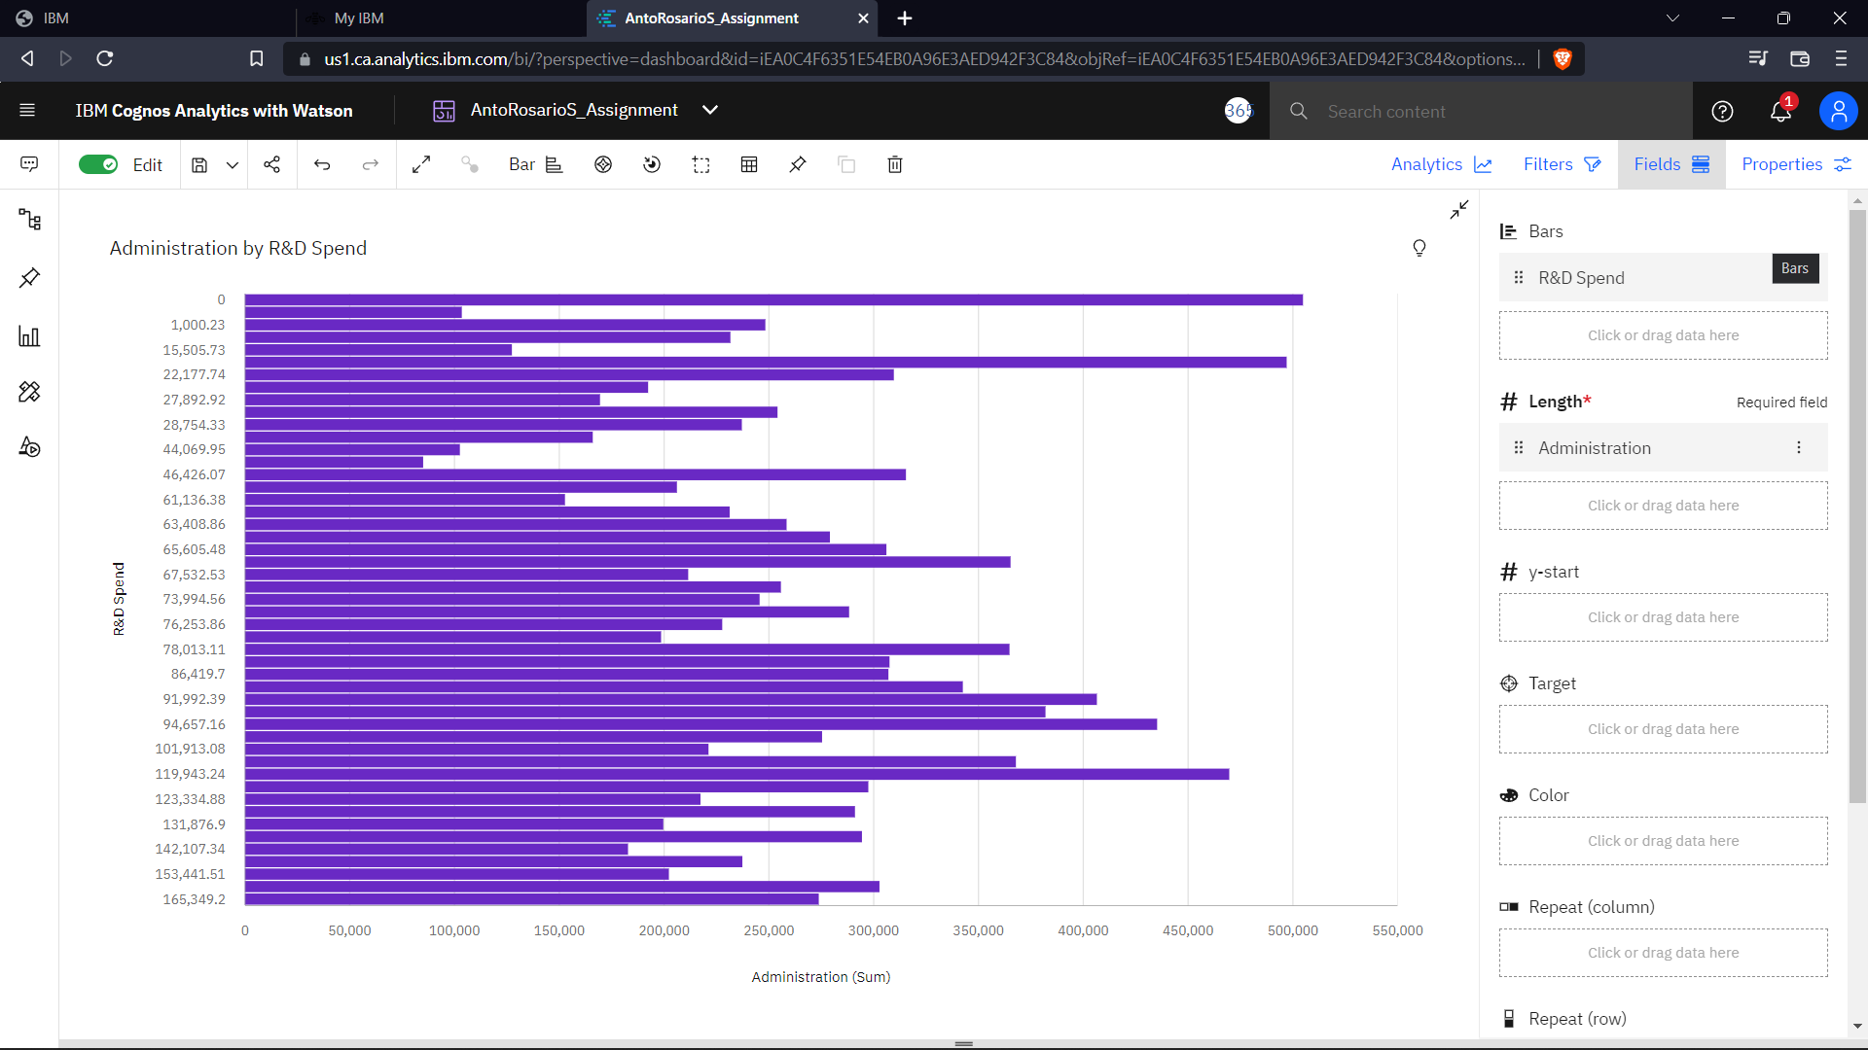

<https://us1.ca.analytics.ibm.com/bi/?perspective=dashboard&pathRef=.my_folders%2FAntoRosarioS_Assignment&action=view&mode=dashboard&subView=model00000183829a25ab_00000000>

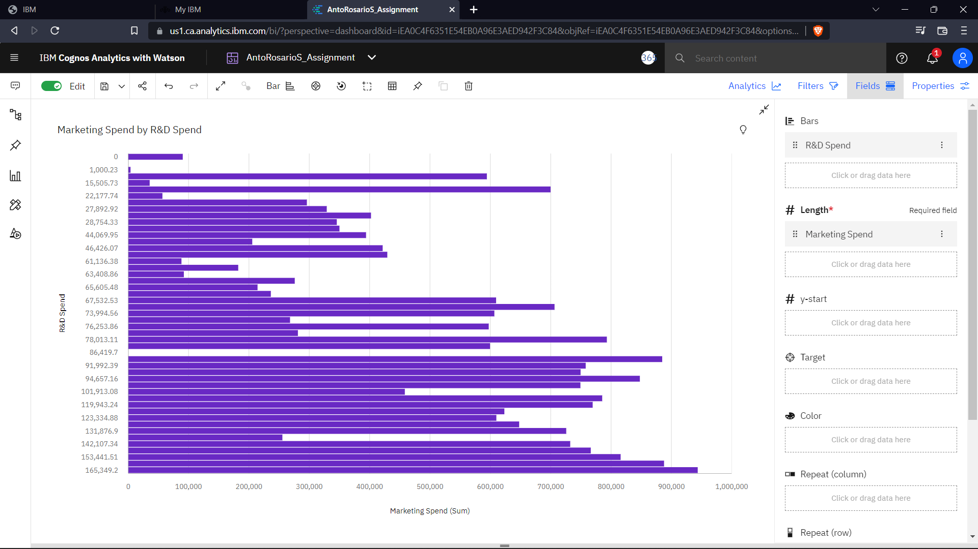

<https://us1.ca.analytics.ibm.com/bi/?perspective=dashboard&pathRef=.my_folders%2FAntoRosarioS_Assignment&action=view&mode=dashboard&subView=model00000183829af74d_00000000>

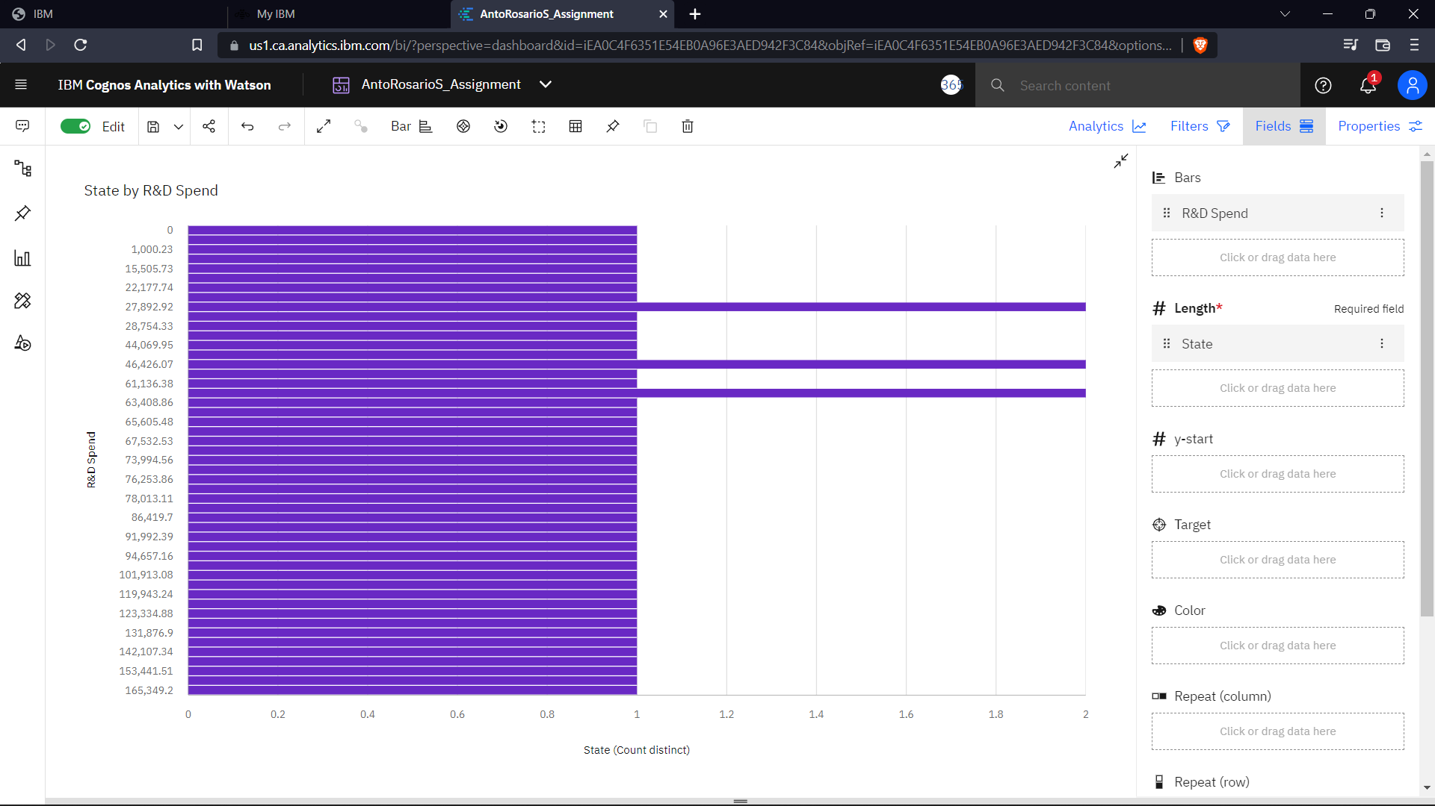

<https://us1.ca.analytics.ibm.com/bi/?perspective=dashboard&pathRef=.my_folders%2FAntoRosarioS_Assignment&action=view&mode=dashboard&subView=model0000018382aa876c_00000000>

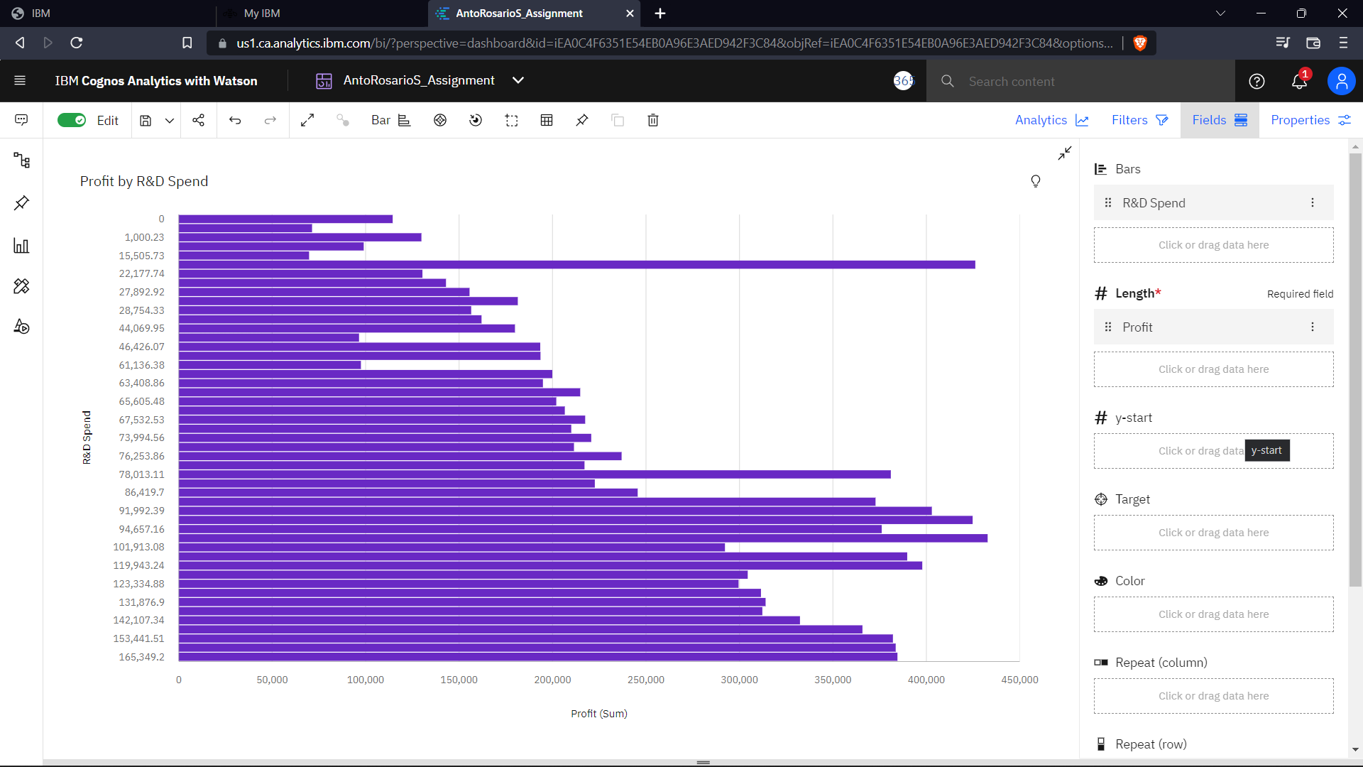

<https://us1.ca.analytics.ibm.com/bi/?perspective=dashboard&pathRef=.my_folders%2FAntoRosarioS_Assignment&action=view&mode=dashboard&subView=model0000018382aef63f_00000000>

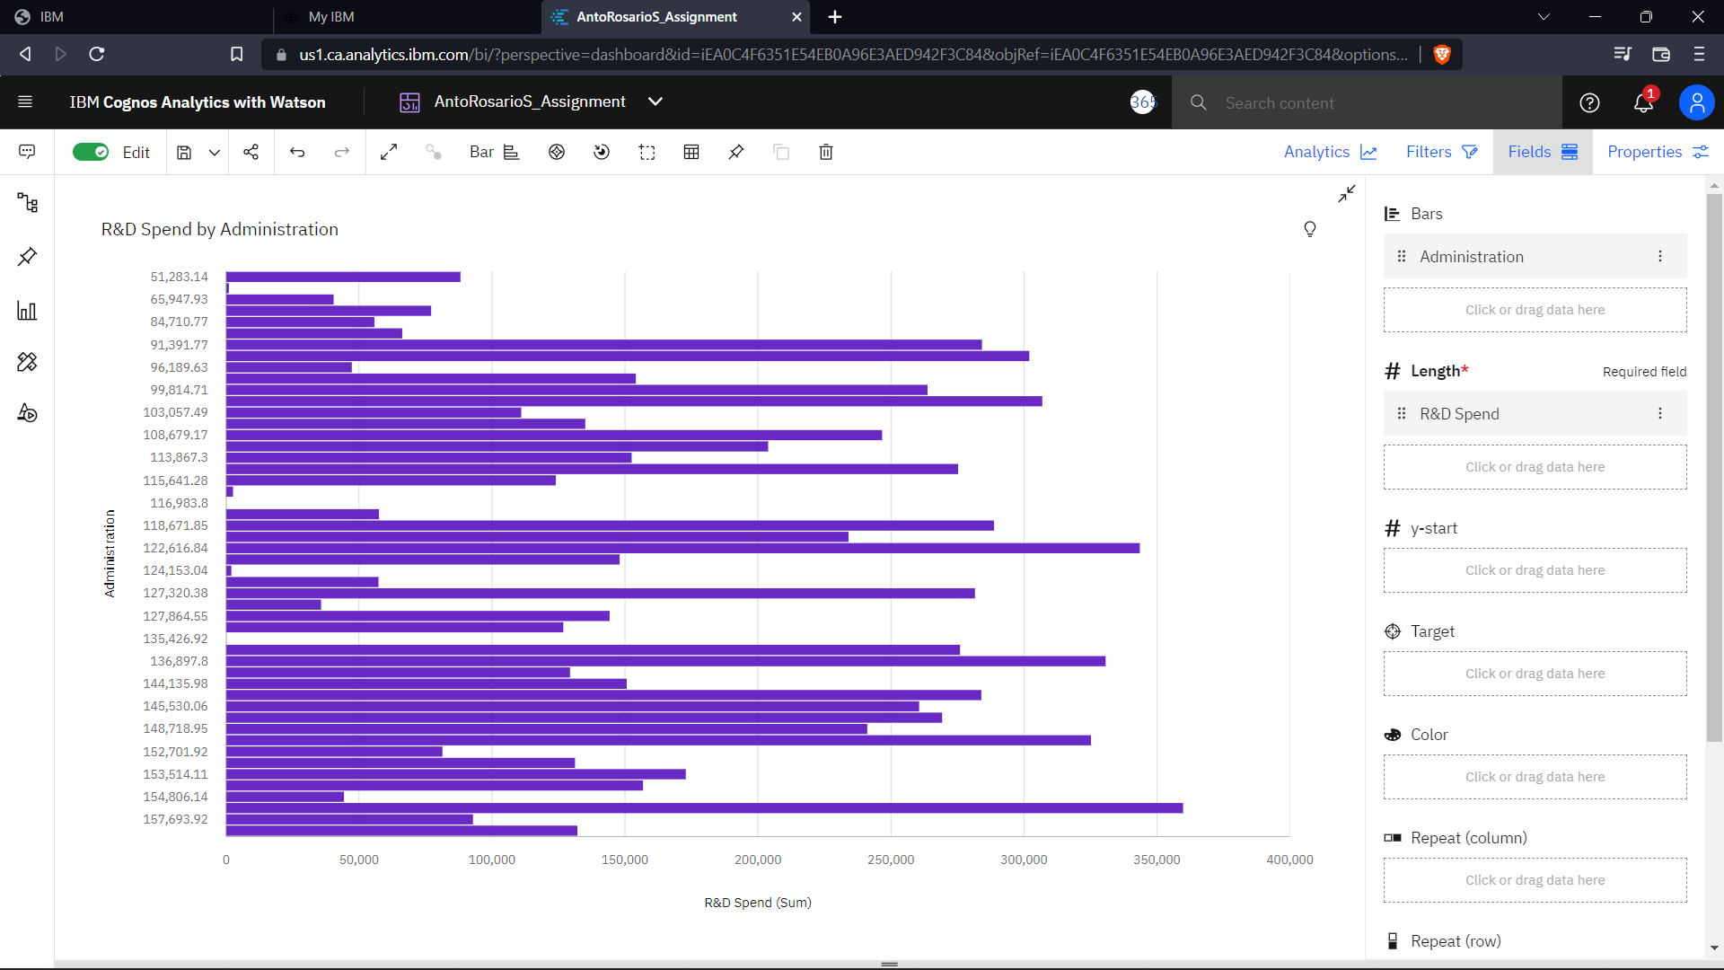<https://us1.ca.analytics.ibm.com/bi/?perspective=dashboard&pathRef=.my_folders%2FAntoRosarioS_Assignment&action=view&mode=dashboard&subView=model0000018382b0ca7b_00000000>

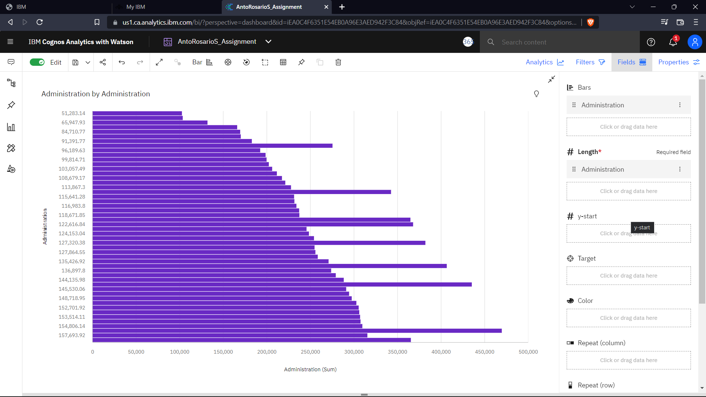

<https://us1.ca.analytics.ibm.com/bi/?perspective=dashboard&pathRef=.my_folders%2FAntoRosarioS_Assignment&action=view&mode=dashboard&subView=model0000018382cb2a31_00000000>

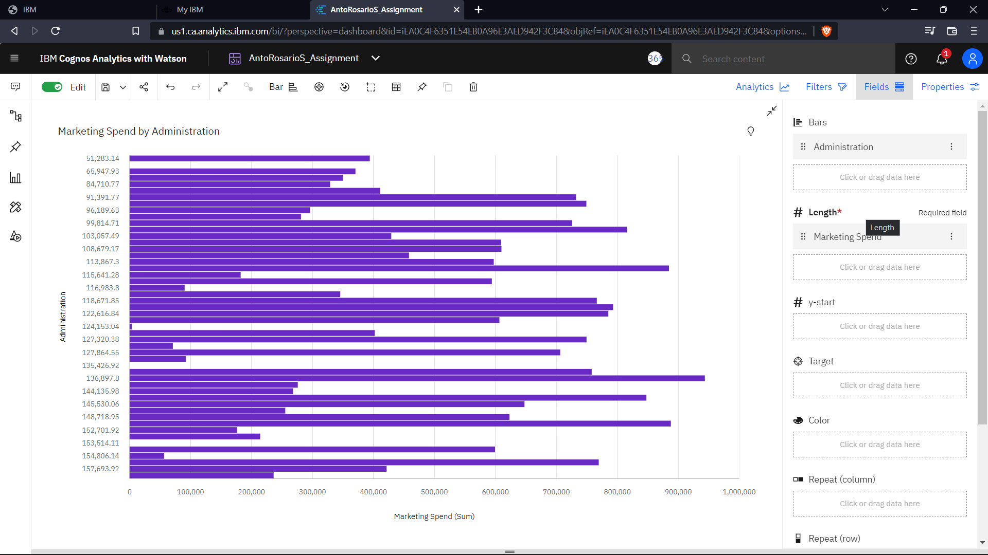<https://us1.ca.analytics.ibm.com/bi/?perspective=dashboard&pathRef=.my_folders%2FAntoRosarioS_Assignment&action=view&mode=dashboard&subView=model0000018382cc5eb8_00000000>

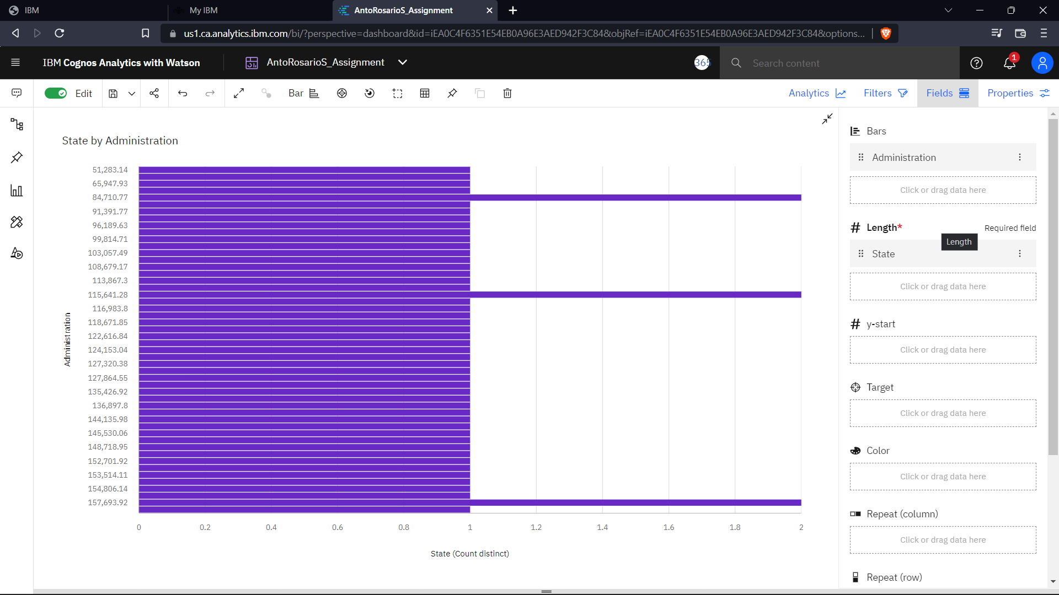

<https://us1.ca.analytics.ibm.com/bi/?perspective=dashboard&pathRef=.my_folders%2FAntoRosarioS_Assignment&action=view&mode=dashboard&subView=model0000018382cd3f8d_00000000>

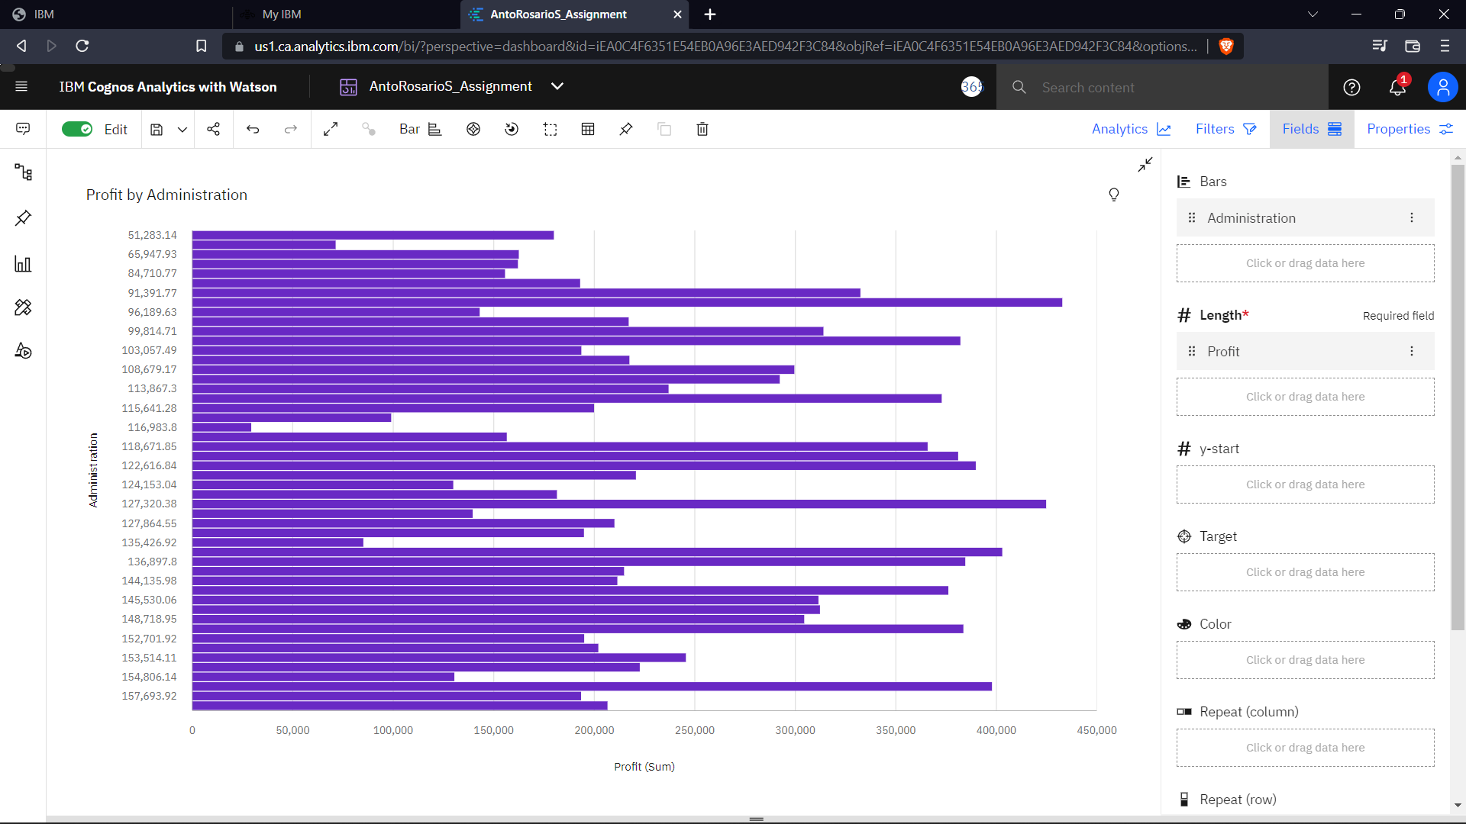

<https://us1.ca.analytics.ibm.com/bi/?perspective=dashboard&pathRef=.my_folders%2FAntoRosarioS_Assignment&action=view&mode=dashboard&subView=model0000018382cf168a_00000000>

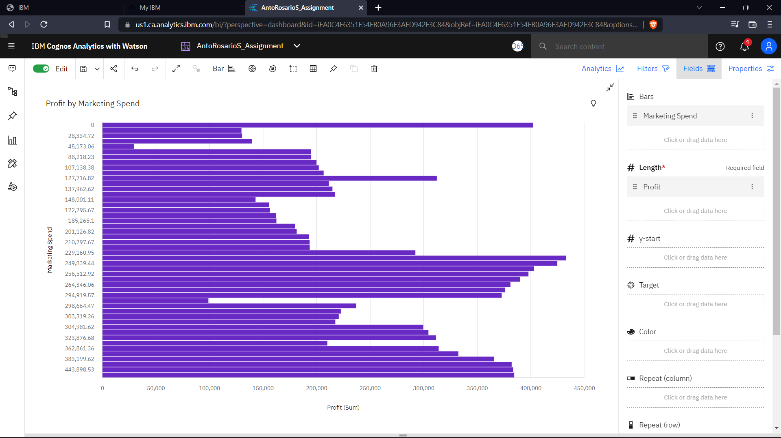

<https://us1.ca.analytics.ibm.com/bi/?perspective=dashboard&pathRef=.my_folders%2FAntoRosarioS_Assignment&action=view&mode=dashboard&subView=model0000018382cfe9f4_00000000>

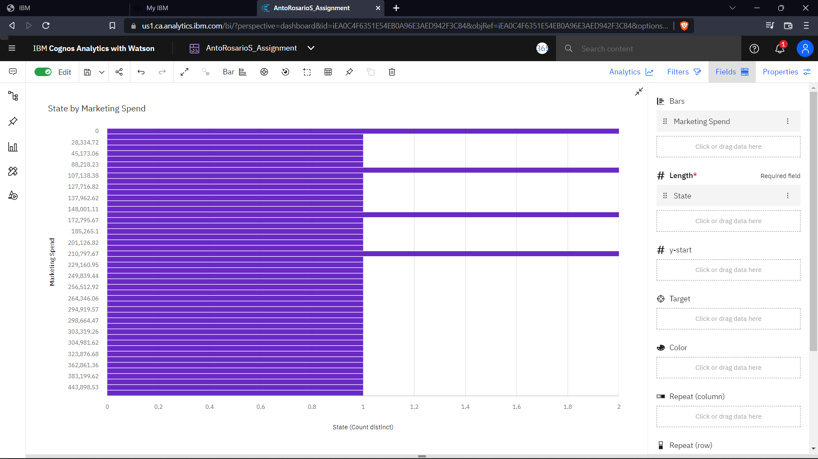

<https://us1.ca.analytics.ibm.com/bi/?perspective=dashboard&pathRef=.my_folders%2FAntoRosarioS_Assignment&action=view&mode=dashboard&subView=model0000018382d0bf51_00000000>

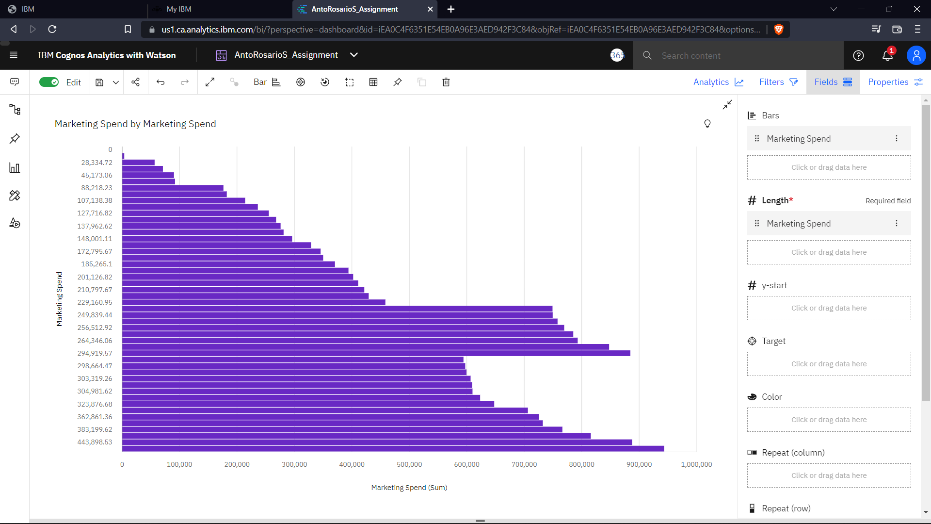<https://us1.ca.analytics.ibm.com/bi/?perspective=dashboard&pathRef=.my_folders%2FAntoRosarioS_Assignment&action=view&mode=dashboard&subView=model0000018382d17d71_00000000>

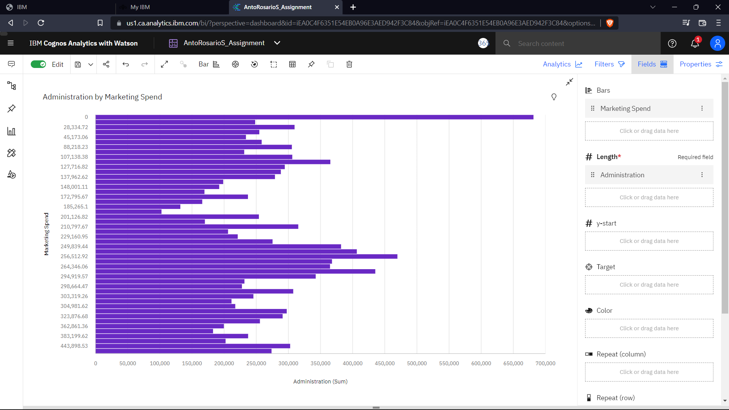<https://us1.ca.analytics.ibm.com/bi/?perspective=dashboard&pathRef=.my_folders%2FAntoRosarioS_Assignment&action=view&mode=dashboard&subView=model0000018382d22aea_00000000>

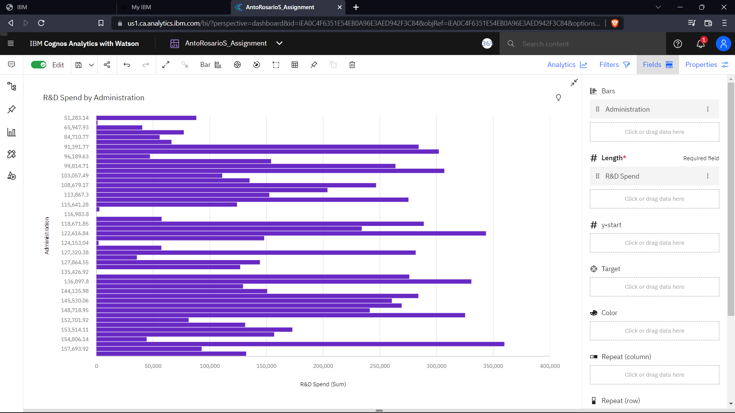

<https://us1.ca.analytics.ibm.com/bi/?perspective=dashboard&pathRef=.my_folders%2FAntoRosarioS_Assignment&action=view&mode=dashboard&subView=model0000018382d2dce1_00000000>